**ONLINE FOOD ORDERING SYSTEM**

**Final Project For SQL Module**

**By Anuvhab Basu**

1.Descripation :

Following database schema is designed to function as a backend storage database for an online food ordering system.

An online food ordering system allows your business to accept and manage orders placed online for delivery or takeway.

Customers browse a digital menu, either on an app or website and place and pay for their order online.

* More accuracy and easy order process.
* Fast, easy and comfortable
* 24*7 customer support
* Mobile friendly.

**This Database Contains 6 Tables:**

1)Customer

2)Menu

3)Order1

4)User

5)Order_details1

6)Payment

Hows these tables/entities are related to each other is shown pictorially on next page through ER diagram, i.e., Entity Relationship Diagram.

**2.E-R Diagram:**

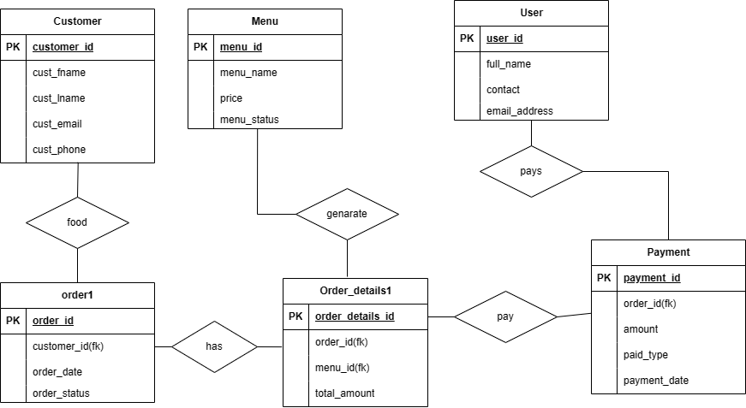

**3.Table description:**

**a)Customer:**

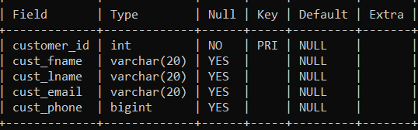

**b)Menu:**

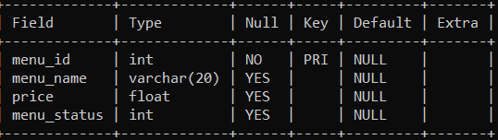

**c)Order1:**

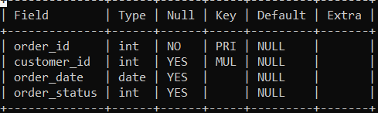

**d)User:**

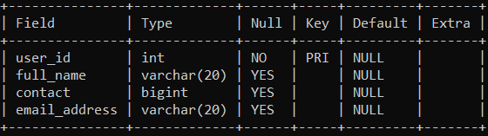

**e) Order_details1:**

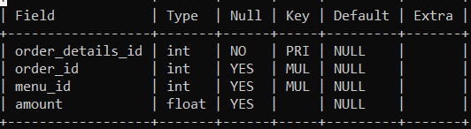

**f) payment:**

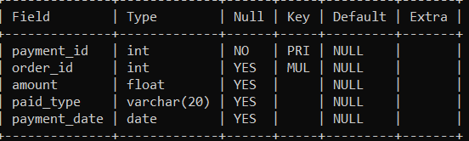

**4.Commands:**

**a)Create database;**

Create database ofos;

**b)Select database;**

Use ofos;

**c)Create table named Customer:**

create table customer(customer_id int primary key not null, cust_fname varchar(20),cust_lname varchar(20),cust_email varchar(20),cust_phone bigint);

**d)Create table named Menu:**

create table menu(menu_id int primary key not null, menu_name varchar(20), price float, menu_status int);

**e)Create table named Order1:**

create table order1(order_id int primary key not null, customer_id int, order_date date, order_status int, foreign key(customer_id) references customer(customer_id));

**f)Create table named User:**

create table user(user_id int primary key not null, full_name varchar(20), contact bigint, email_address varchar(20));

**g)Create table named order_details1:**

create table order_details1(order_details_id int primary key not null, order_id int, menu_id int, amount float, foreign key(order_id) references order1(order_id),foreign key(menu_id) references menu(menu_id));

**h)Create table named payment:**

create table payment(payment_id int primary key not null, order_id int, amount float, paid_type varchar(20), payment_date date, foreign key(order_id)references order1(order_id));

**i)Populate Customer values:**

insert into customer values:

(1,"divya","gurav","dgurav@gmail.com","9356865016");

(2,"virat","shinde","virats@gmail.com","9987828217");

(3,"sanjay","dhamnak","sadhamnak@gmail.com","9082663617");

(4,"rani", "pawar", "rpawar@gmail.com", "7584584662");

(5,"mahi","solkar","ms@gmail.com","935682452");

(6,"sahil","gurav","sgurav@gmail.com","754854854");

(7,"shrutika","dalvi","dalvis@gmail.com","754854854");

(8,"vidya","suvre","suvrev@gmail.com","9321113673");

(9,"sona","devkad","devkads@gmail.com","9321113673");

(10,"mamata","balye","mamatab@gmail.com","885474545");

**j)Populate Menu values:**

insert into menu values:

(11,"burger",255,30);

(12,"sandwich",130,25);

(13,"french fries",129,15);

(14,"cake",600,10);

(15,"chinese",300,15);

(16,"chicken curry",400,45);

(17,"roti",20,35);

(18,"fried rice",180,60);

(19,"pepsi",60,45);

(20,"pizza",425,385);

**k)Populate Order1 values:**

insert into order1 values;

(101,1,"2023-08-30",45),

(102,5,"2023-07-12",35);

(103,2,"2023-06-25",25),

(104,6,”2023-08-21”,15);

(105,4,"2023-05-15",20);

(106,6,"2023-04-15",10),

(107,8,"2023-07-15",45),

(108,10,"2023-06-23",65),

(109,9,"2023-08-25",25);

(110,2,"2023-05-10",25);

**l)Populate User values:**

insert into user values:

(201,"virat kolhi","935686514","vk@gmail.com");

(202,"mahi dhoni","935686514","msdgmail.com");

(203,"sai gomane","85878545","saig@gmail,com");

(204,"aarti pawar","932111673","aap@gmail.com");

(205,"aashu shitap","56825454","ash@gmail.com");

(206,"shreyash gurav","8598466","sgurav@gmail.com");

(207,"sandhya shitap","8598466","sgurav@gmail.com");

(208,"sai joshi","8598466","saij@gmail.com");

**m)Populate Order_details1:**

insert into user values:

(1001,101,12,25),

(1002,105,15,300),

(1003,104,13,450),

(1004,110,19,600);

(1005,106,14,750),

(1006,108,18,800),

(1007,101,11,120),

(1008,106,16,650),

(1009,104,17,100),

(10010,102,11,450),

(10011,103,15,200);

**n)Populate Payment:**

insert into payment values:

(201,102,250,"cash","2023-08-30");

(202,104,50,"debit card","2023-08-30");

(203,101,100,"debit card","2023-07-15");

(204,105,50,"credit card","2023-07-15");

(205,106,250,"upi payment","2023-05-20");

(206,102,250,"cash","2023-05-20");

(207,109,175,"credit card","2023-04-15");

(209,105,450,"cash","2023-08-12");

(210,108,600,"debit card","2023-08-12");

**5.Sub-queries:**

**1.Display names of customer name who have order_status 25;**

SELECT cust_fname FROM customer WHERE customer_id IN

(select customer_id from order1 where order_status = 25);

**Result:**

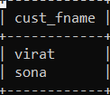

**2. Retrieve the total amount paid by the customer with customer id 6 for all their orders:**

SELECT SUM(amount)

FROM Payment

WHERE order_id IN (SELECT order_id FROM Order1 WHERE customer_id = 6);

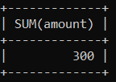

**3. Retrieve the names of customers who have ordered the most expensive item from the menu.**

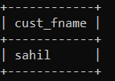

**6.Join:**

1. **Retrieve the details of orders along with the corresponding customer names for orders that have been paid.**

SELECT o.order_id, c.cust_fname

FROM Order1

INNER JOIN Customer ON o.customer_id = c.customer_id

WHERE o.order_id IN (

SELECT p.order_id

FROM Payment p);

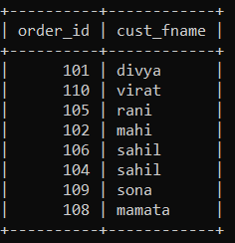

1. **Retrieve the details of orders along with the corresponding menu items and their prices for a specific customer.**

SELECT o.order_id, m.menu_name, m.price

FROM Order1 o

JOIN Order_details1 od ON o.order_id = od.order_id

JOIN Menu m ON od.menu_id = m.menu_id

WHERE o.customer_id = 4;

